**## Self-efficacy in classroom management**

While teachers are exposed to many stressors that might cause negative emotions when teaching, student misbehavior in particular has been found to be a significant predictor of teacher stress [@boyle1995structural]. Although all actors in the classroom can be disturbed, the perception varies depending on their role. Students, while equally likely to feel disturbed, are on average less sensitive than teachers (Infantino & Little, 2005; Montuoro & Lewis, 2015). The explanation for this lies in the linkage of actors' perceptual patterns to their roles (Wettstein et al., 2016). In addition, there are personal and contextual factors (Eckstein, 2018; Makarova et al., 2014). Personal characteristics on the teacher's side can be a low sense of self-efficacy or affect-driven acting, which can lead to a negative emotional state even before a disruption and thus negatively influences the perception of disruption (Frenzel & Götz, 2007).

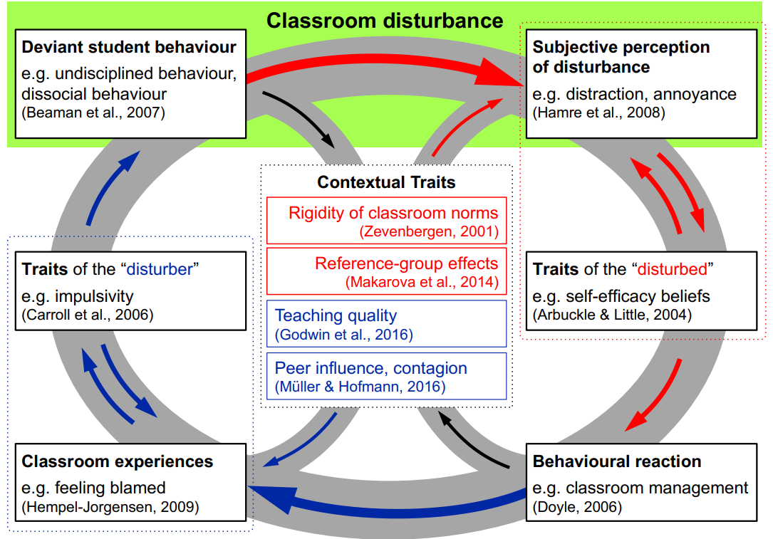Figure 1: Interactionist model of the production and perception of classroom disturbances [@eckstein2021conditions]

Research has shown that teachers' self-efficacy in classroom management and dealing with disruptions is an important protective factor in preventing stress, emotional exhaustion and burnout [@friedman2003self; @dicke2014self]. Teachers' self-efficacy beliefs, i.e., the subjective assessment of the controllability of situations, are considered to be an important determinant of the experience of emotions. Further, teachers’ individual perceptions and evaluations of student misbehavior are closely related to their well-being [@aldrup2018student].